WEEK 4: SYSTEM DEVELOPMENT II

I. INTENDED LEARNING OUTCOME (ILO)
At the end of this laboratory activity, students should be able to:
Develop and integrate advanced system modules by implementing authentication and security features, integrating front-end and back-end components, and demonstrating functional interaction among major system modules in accordance with approved project requirements.

II. PERFORMANCE TASK
Following the completion of initial module development during Week 3, your team must continue system development by implementing advanced functionalities, securing user access through authentication and authorization mechanisms, and integrating front-end interfaces with back-end services and databases.
The outputs for this week should demonstrate that the project is transitioning from isolated module development into an integrated working system.

III. WEEK 4 ACTIVITIES
Activity 1 – Development Progress Review
Activity 2 – Advanced Module Development
Activity 3 – Authentication and Security Implementation
Activity 4 – Front-End and Back-End Integration
Activity 5 – Integration Testing
Activity 6 – Repository Update and Documentation
Activity 7 – Progress Report No. 2 and Adviser Consultation

ACTIVITY 1
DEVELOPMENT PROGRESS REVIEW

Purpose
To evaluate the completion status of Week 3 outputs and identify remaining development tasks.
Procedure
- Review Progress Report No. 1.
- Review completed modules.
- Identify unfinished functionalities.
- Assign development tasks for Week 4.
- Complete Form 1.

FORM 1
DEVELOPMENT TASK ASSIGNMENT

Directions
List the remaining functionalities and assign responsible team members.

Functionality / Module | Assigned Member | Priority | Target Completion
Detection fix — suppress the MAC-spoofing false positive caused by the router relaying ARP from its second radio. | Bueno, Jannces G. | High | 8/14/2026
Detection fix — suppress the rogue-DHCP false positive caused by the monitoring machine’s own virtual adapter. | Bueno, Jannces G. | High | 8/14/2026
Device list ordering — sort IP addresses numerically instead of alphabetically. | Attaban, Quincy Joy B. | Medium | 8/14/2026
Settings synchronisation — return the live monitoring state so the dashboard switch reflects it correctly. | Gulla, Ma. Leonora M. | Medium | 8/14/2026
Report filtering — allow reports to be filtered by date range and severity before export. | Attaban, Quincy Joy B. | Medium | 8/14/2026
Expanded automated test coverage for the corrected detection rules. | Gulla, Ma. Leonora M. | Low | 8/14/2026
Expected Outputs
☑ Advanced Functional Modules
☑ Authentication Module
☑ Integrated Components

ACTIVITY 2
ADVANCED MODULE DEVELOPMENT

Purpose
To continue the implementation of core and supporting system functionalities.
Procedure
- Develop remaining modules identified in the project plan.
- Apply coding standards established in Week 2.
- Conduct developer-level testing.
- Upload source code to repository.
- Complete Form 2.

FORM 2
ADVANCED MODULE DEVELOPMENT REPORT

Directions
Document all modules developed during Week 4.

Module | Description | Status
Threat Detection Engine (advanced tiers) | Extended beyond basic signature matching: low-and-slow scan tier, stealth TCP flag detection, UDP scan detection, and active re-probing before an alert is raised. | Completed
Public Status Page | Login-free safety page serving a SAFE / CAUTION / THREATS DETECTED verdict to any device on the Wi-Fi, exposing no device identifiers. | Completed
Reporting Module | Four report types generated as CSV or PDF, with every export recorded in the reports table. | Completed
Data Retention Module | Scheduled purge of expired connection, threat and administrator log rows, with WAL checkpointing to reclaim disk space. | Completed
Automated Test Suite | 51 automated tests covering detection accuracy, access control and the database layer. | Completed
Detection false-positive corrections | Suppression of the router-radio ARP relay and virtual-adapter DHCP false positives identified during Week 3 testing. | In Progress

Functionality Verification
Test Conducted | Result
Input Processing | Pass
Data Validation | Pass
Business Logic Execution | Pass
Output Generation | Pass
Required Evidence
☑ Screenshots of Module
☑ Source Code Screenshot
☑ Demonstration Screenshot

Screenshots of Module
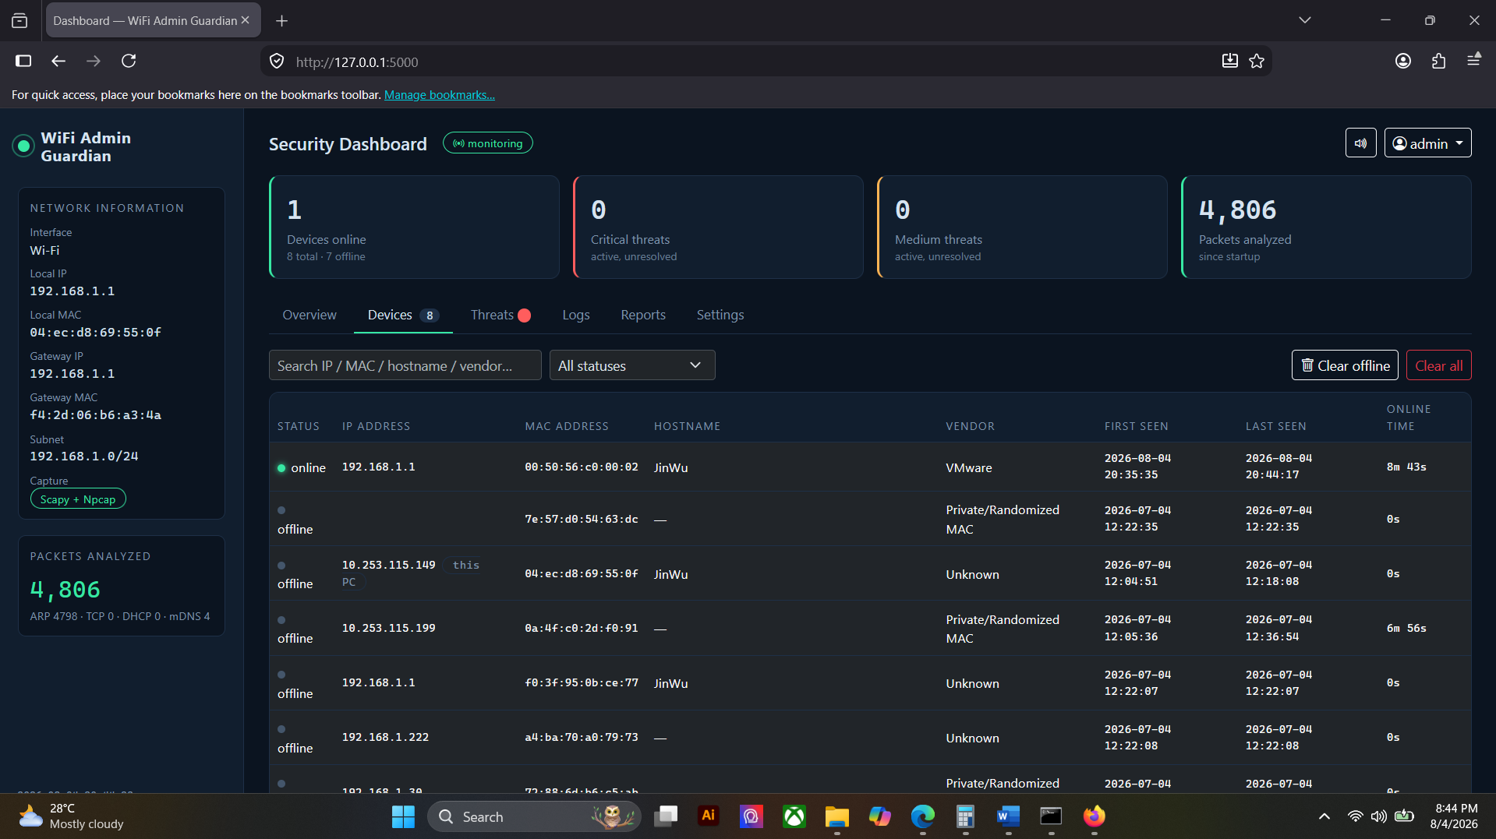

Source Code Screenshot
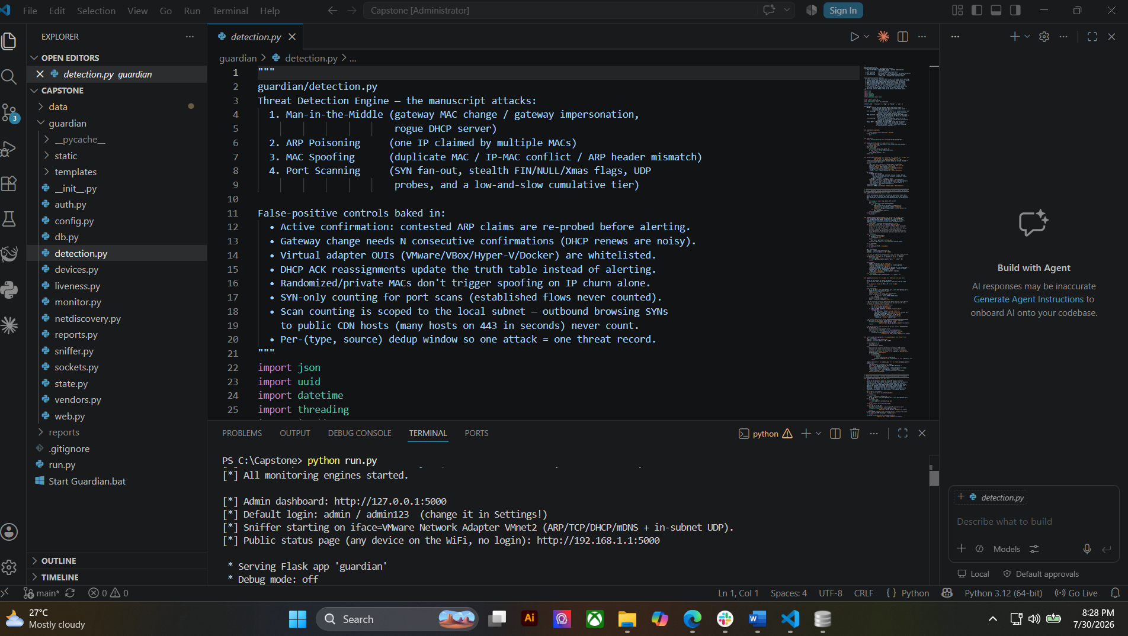
Demonstration Screenshot
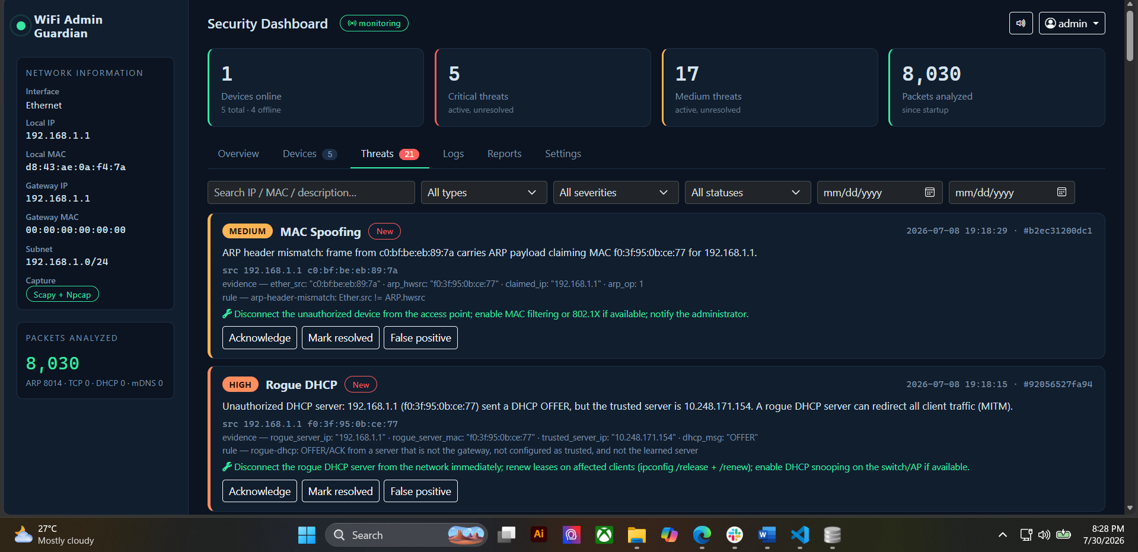

ACTIVITY 3
AUTHENTICATION AND SECURITY IMPLEMENTATION

Purpose
To implement user authentication, authorization, and basic security controls.
Procedure
- Develop login and logout functionalities.
- Implement user role management.
- Configure access permissions.
- Apply password protection mechanisms.
- Test authentication processes.
- Complete Form 3.

FORM 3
AUTHENTICATION AND SECURITY IMPLEMENTATION REPORT

Directions
Indicate the security features implemented in the system.
Security Feature | Implemented | Remarks
Login Authentication | ☑ | Username and password verified against a bcrypt hash (cost factor 12). Credentials are never stored in plain text.
Logout Function | ☑ | Session cleared on logout and the action written to the administrator log.
Password Validation | ☑ | Minimum length of 8 characters, confirmation field must match, and the current password is re-verified before any change.
Role-Based Access Control | ☐ | Not applicable to the approved design, which specifies a single administrator account. Access is controlled by authentication: every administrative function requires a valid session.
Session Management | ☑ | Server-side sessions with a 60-minute idle timeout; cookies are HttpOnly with SameSite protection.
Input Validation | ☑ | CSRF tokens on all state-changing requests, parameterised SQL statements throughout, and range checks on all settings values.
Authentication Testing Results
Test Scenario | Result
Valid Login Credentials | Pass
Invalid Login Credentials | Pass
Unauthorized Access Attempt | Pass
Session Timeout Test | Pass
Required Evidence
☑ Login Screen Screenshot
☐ User Role Management Screenshot
☑ Authentication Test Results

Login Screen Screenshot
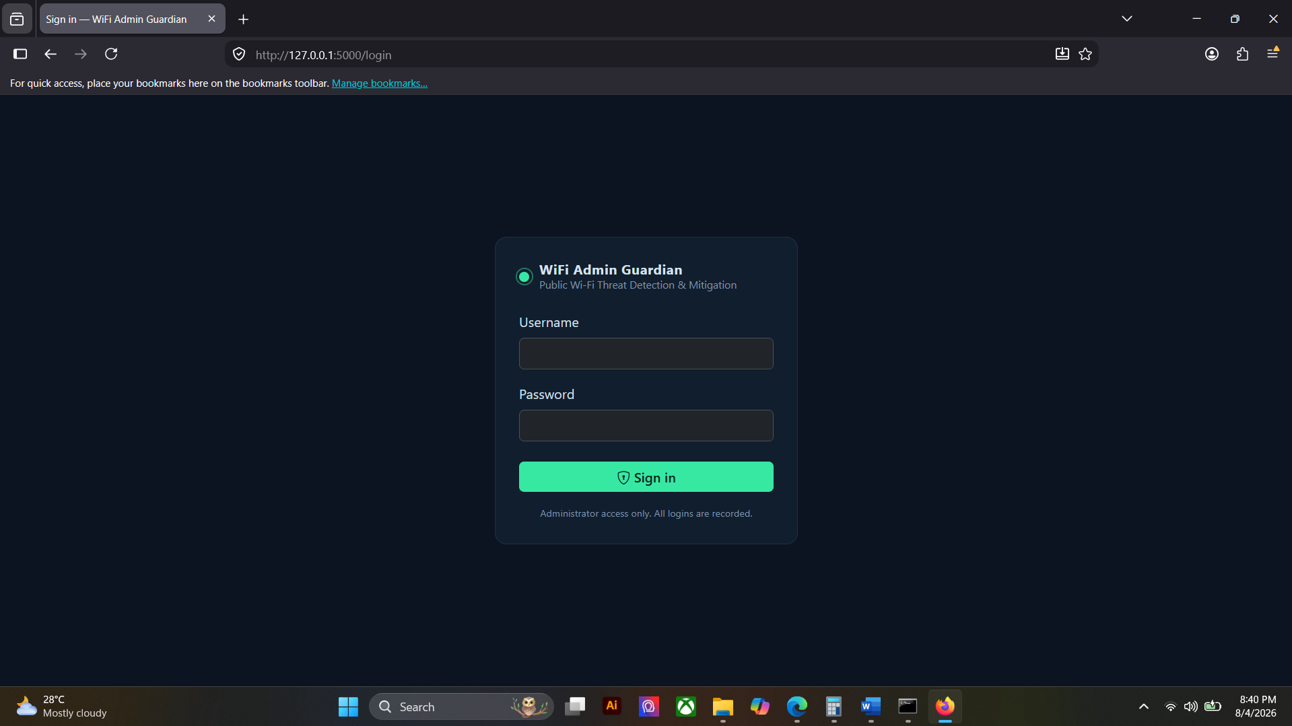

Authentication Test Results
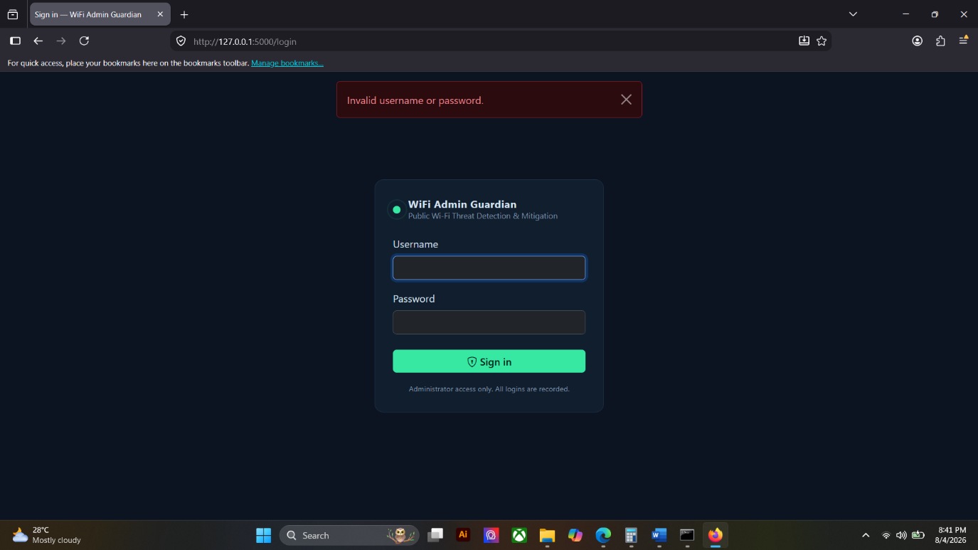

ACTIVITY 4
FRONT-END AND BACK-END INTEGRATION

Purpose
To establish communication between user interfaces, application logic, and database components.
Procedure
- Connect front-end forms to back-end services.
- Configure database transactions.
- Verify data flow between components.
- Test create, read, update, and delete (CRUD) operations.
- Complete Form 4.

FORM 4
SYSTEM INTEGRATION REPORT

Directions
Document the integrated components of the system.
Component Integrated | Status | Remarks
User Interface ↔ Back-End | Integrated | Dashboard pages call the REST API for data and receive live updates through Socket.IO, so screens refresh without reloading.
Back-End ↔ Database | Integrated | All modules read and write through a shared thread-safe SQLite layer with serialised writes and WAL journaling.
Authentication ↔ Database | Integrated | Credentials verified against the admins table; every login, logout and settings change is written to the administrator log.
Reporting ↔ Database | Integrated | Reports query the threats, devices and log tables, and each export is recorded back into the reports table.
CRUD Functionality Verification
Function | Result
Create | Pass
Read | Pass
Update | Pass
Delete | Pass
Required Evidence
☑ Data Entry Demonstration
☑ Database Update Screenshot
☑ Integration Demonstration Screenshot

Data Entry Demonstration
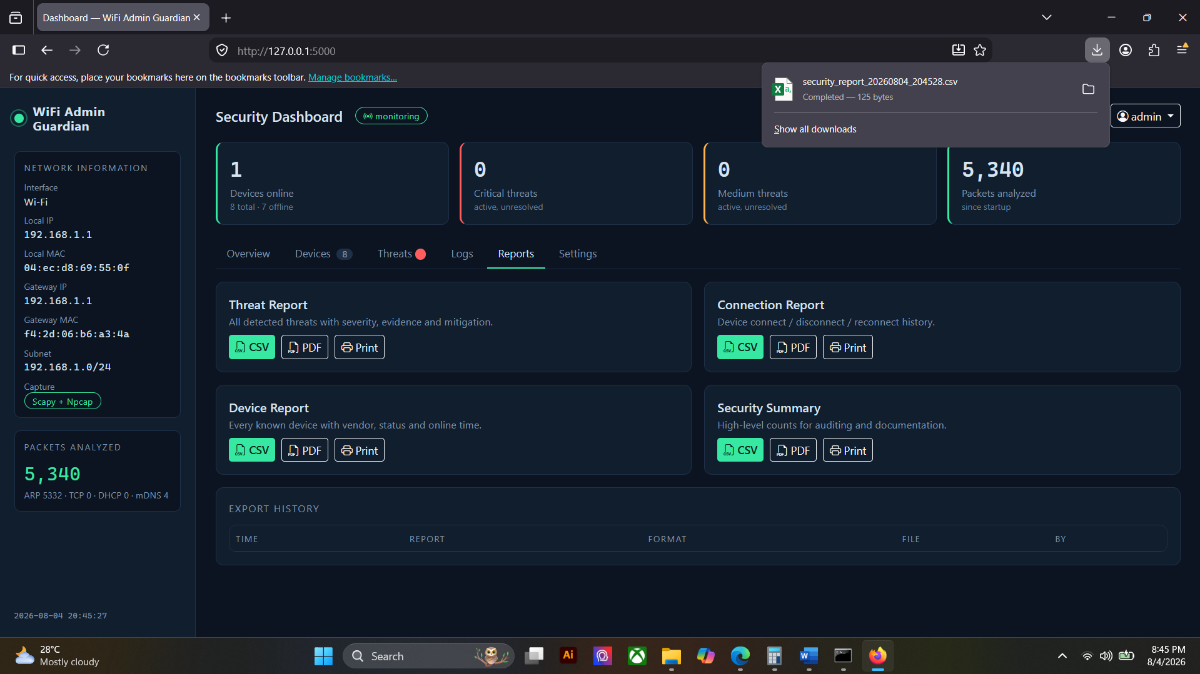

Database Update Screenshot
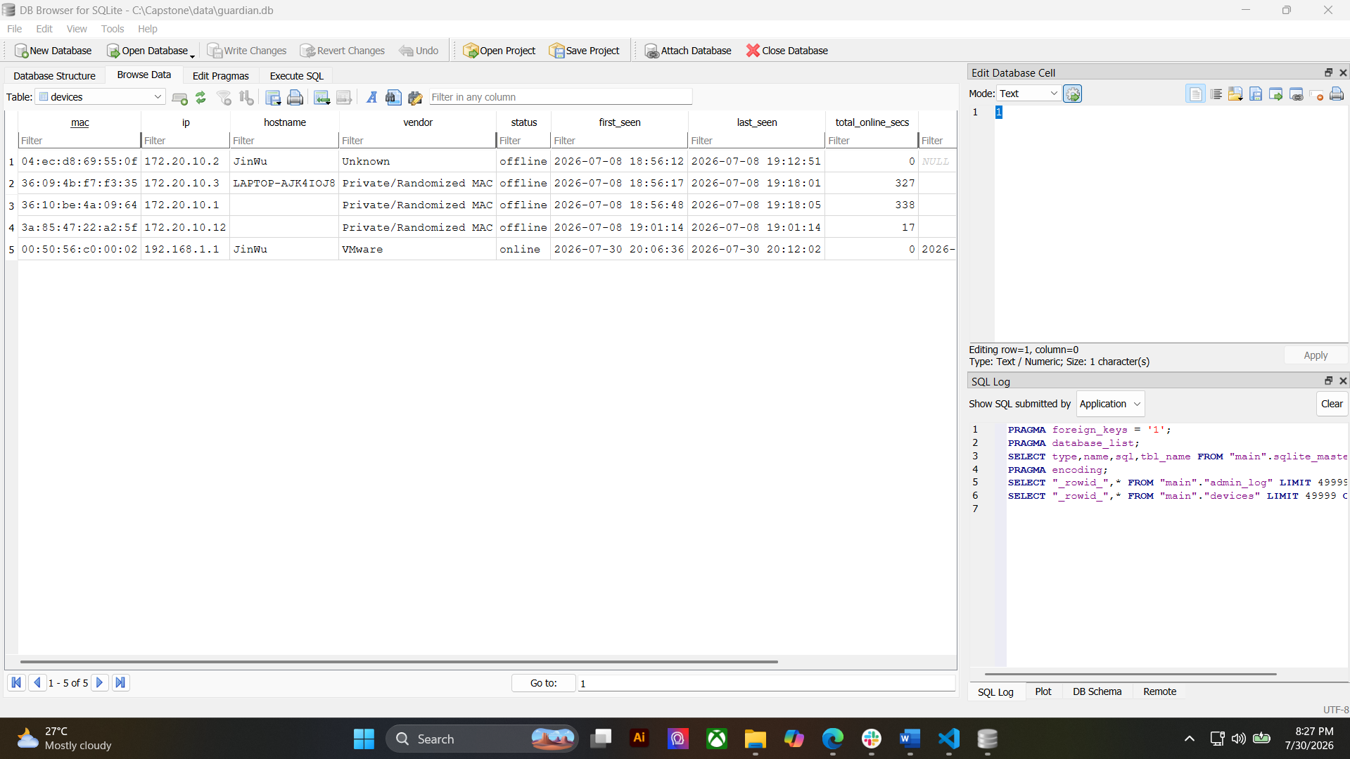

Integration Demonstration Screenshot
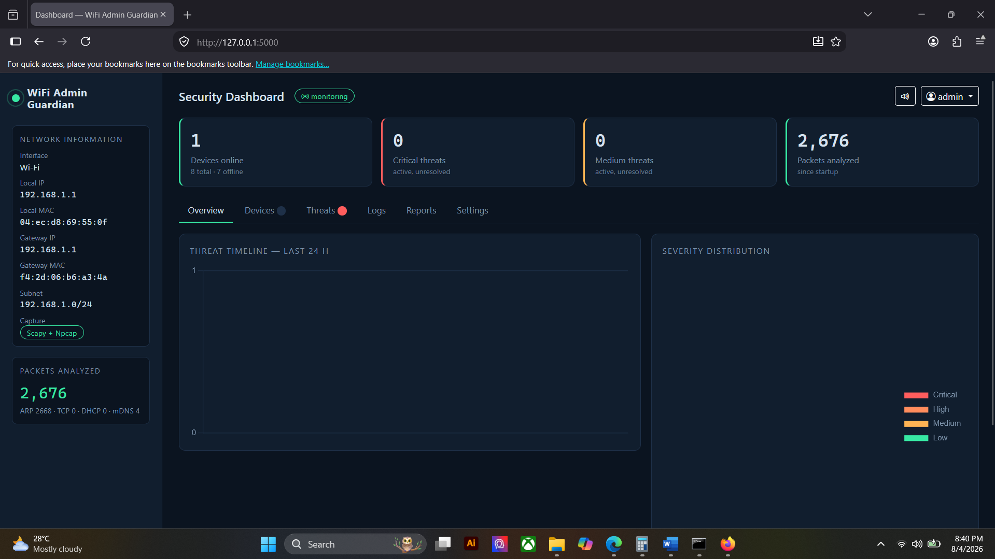

ACTIVITY 5
INTEGRATION TESTING

Purpose
To verify that integrated modules work together correctly.
Procedure
- Execute end-to-end system transactions.
- Observe system responses.
- Record issues encountered.
- Implement corrective actions.
- Complete Form 5.

FORM 5
INTEGRATION TESTING CHECKLIST

Directions
Test integrated modules and record results.
Test Case | Expected Result | Actual Result | Status
Administrator logs in with valid credentials | Session created and dashboard displayed | Dashboard displayed as expected | Pass
Administrator logs in with invalid credentials | Access denied and attempt recorded | Error shown and entry written to admin log | Pass
Unauthenticated user opens an administrator page | Request rejected or redirected | Redirected to the public status page | Pass
New device joins the monitored network | Device appears in the registry and dashboard | Device listed within seconds and stored in the database | Pass
Device disconnects from the network | Status changes to offline and event is logged | Marked offline in 6–10 seconds and logged | Pass
Suspicious traffic pattern is generated | Threat detected, stored and displayed live | Threat raised with evidence and pushed to the dashboard | Pass
Administrator marks a threat as Resolved | Status updated in database and interface | Status updated and reflected immediately | Pass
Administrator exports a report | File generated, downloaded and logged | CSV generated with correct data and recorded in reports table | Pass
Settings changed and saved | Values persisted and applied to monitoring | Values stored and used by the liveness prober | Pass
Public status page opened without login | Verdict shown without exposing device data | Verdict displayed; no MAC or IP addresses present | Pass
Issues Identified
Issue | Severity | Action Taken
MAC-spoofing false positive raised when the router relays ARP traffic from its second radio on behalf of a client. | Medium | Reproduced and assigned in Form 1. Correction in progress: frames originating from the gateway’s own MAC family will be excluded.
Rogue-DHCP false positive raised by the monitoring machine’s own virtual adapter. | Medium | Reproduced and assigned in Form 1. Correction in progress: the monitor’s own adapters will be excluded from DHCP server checks.
Device list sorts IP addresses alphabetically, so 192.168.1.10 appears before 192.168.1.2. | Low | Assigned in Form 1. Numeric address sorting to be applied.
The monitoring switch on the Settings page does not reflect the live monitoring state. | Low | Assigned in Form 1. The settings endpoint will return the live state so the interface can display it correctly.
Tester Information
Conducted By: | Quincy Joy B. Attaban, Jannces G. Bueno, Ma. Leonora M. Gulla
Date: | 8/11/2026

ACTIVITY 6
REPOSITORY UPDATE REPORT

Purpose
To document all development activities uploaded to the repository.
Procedure
- Commit all completed code.
- Update documentation.
- Record development milestones.
- Complete Form 6.

FORM 6
REPOSITORY UPDATE REPORT

Repository URL: | https://github.com/jannces/Capstone2
Commits Made This Week
Commit Description | Date
Create README.md | Aug 11, 2026
Add files via upload | Aug 7, 2026
Add files via upload | Aug 7, 2026
Add files via upload | Aug 7, 2026
Add files via upload | Aug 7, 2026
Repository Evidence
☑ Updated Source Code
☑ Commit History Screenshot
☑ Branch Update Screenshot
☑ Team Contribution Screenshot

Updated Source Code
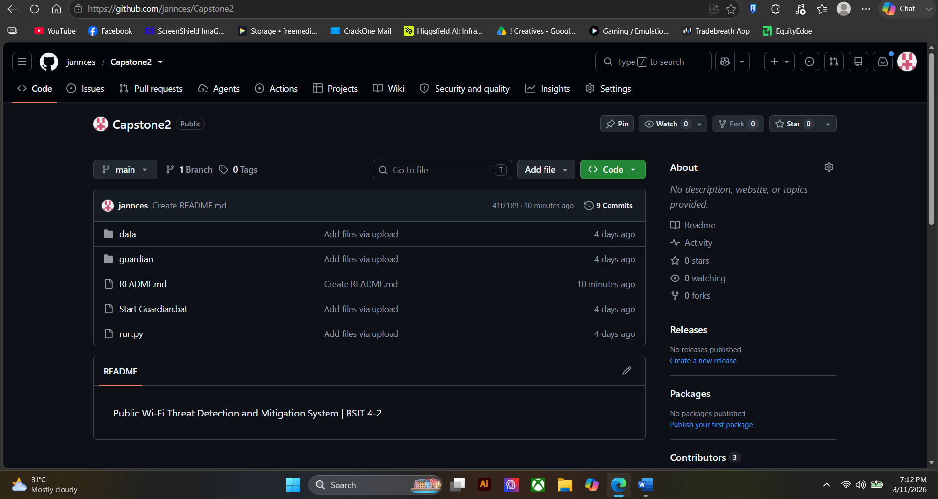
Commit History Screenshot
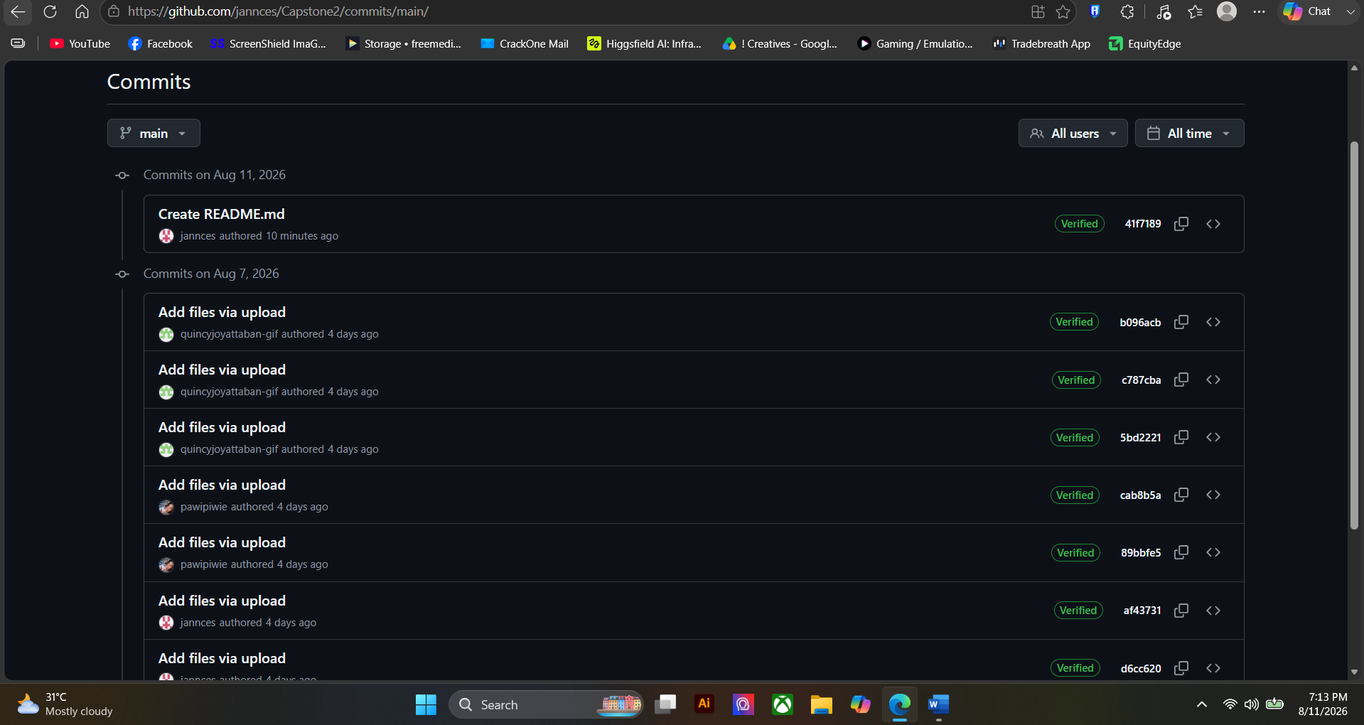

Branch Update Screenshot
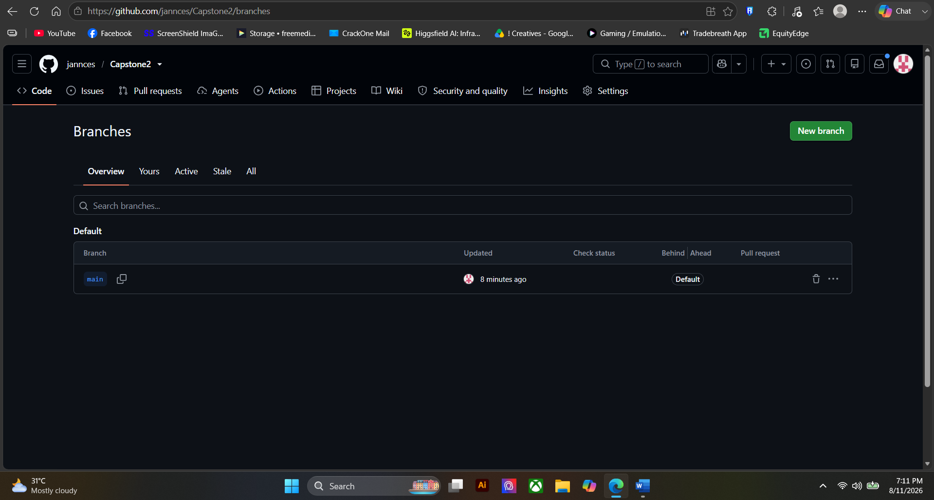
Team Contribution Screenshot
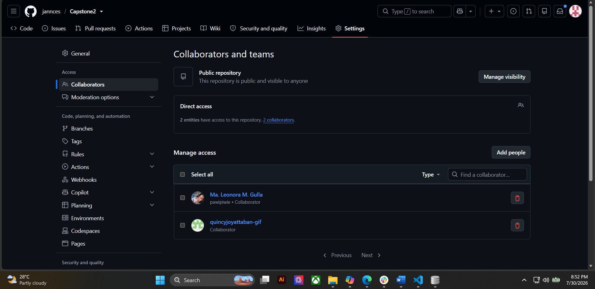

ACTIVITY 7
PROGRESS REPORT NO. 2

Purpose
To summarize development accomplishments and evaluate readiness for system integration and alpha version preparation.
Procedure
- Review all completed activities.
- Summarize development accomplishments.
- Identify issues encountered.
- Describe corrective actions taken.
- Identify Week 5 targets.
- Complete Form 7.

FORM 7
PROGRESS REPORT NO. 2
Project Information
Project Title: | Public Wi-Fi Threat Detection and Mitigation System
Date Submitted: | 8/12/2026
Accomplishments This Week
Activity | Status
Advanced Module Development | In Progress
Authentication Implementation | Completed
Front-End and Back-End Integration | Completed
Integration Testing | Completed
Major Accomplishments
• Completed full front-end and back-end integration: the interface communicates with the application layer through a REST API and receives live updates over Socket.IO.
• Verified all four CRUD operations across devices, threats, logs, settings and reports.
• Implemented the security controls required by the approved design — login authentication, logout, password validation, session management and input validation.
• Passed all four authentication test scenarios, including unauthorized access and session timeout.
• Completed integration testing with ten end-to-end test cases, all passing, supported by an automated suite of 51 tests.
• Confirmed that the public status page exposes no device identifiers.
Challenges Encountered
• Two detection false positives carried over from Week 3 remain unresolved: the router relaying ARP from its second radio, and the monitoring machine’s own virtual adapter appearing as a DHCP server.
• Both false positives are difficult to separate from genuine attacks, because the traffic patterns are technically identical to the attacks being detected.
• Two minor interface defects were found during integration testing: alphabetical IP sorting and a monitoring switch that does not reflect the live state.
Corrective Actions Taken
• All outstanding functionalities were documented and assigned to specific team members with priorities and target dates in Form 1.
• Each false positive was reproduced and its root cause identified before any correction was attempted.
• The automated test suite was used as a regression safety net so that suppressing a false positive cannot silently weaken genuine detection.
• Integration testing was completed early so that the remaining work is limited to isolated modules rather than system-wide changes.
Planned Activities for Week 5
• Finish the two detection corrections and add regression tests for each.
• Apply the two interface corrections identified during integration testing.
• Add date-range and severity filtering to the reporting module.
• Conduct controlled attack simulations to measure detection rate, false-positive rate and response time.
• Prepare the alpha version of the system for evaluation.

Prepared by: | Reviewed by:
Jannces G. Bueno | Romero Dante C. Salum, DIT
Group Leader | Project Adviser

FORM 8
ADVISER CONSULTATION RECORD

Directions
Present all Week 4 outputs and obtain adviser feedback.
Topic Discussed | Recommendation
Module Development Progress
Authentication and Security Features
System Integration
Repository Updates
Readiness for Alpha Version
Adviser Remarks
Required Actions Before Week 5

Adviser Signature: ______________________ | Date: ______________________

V. REQUIRED WEEK 4 SUBMISSION
- Form 1 – Development Task Assignment
- Form 2 – Advanced Module Development Report
- Form 3 – Authentication and Security Implementation Report
- Form 4 – System Integration Report
- Form 5 – Integration Testing Checklist
- Form 6 – Repository Update Report
- Form 7 – Progress Report No. 2
- Form 8 – Adviser Consultation Record
- Screenshots and Supporting Evidence

VI. WEEK 4 DELIVERABLES
✓ Progress Report No. 2
✓ Integrated Functional Modules
✓ Authentication and Security Features
✓ Front-End and Back-End Integration
✓ Integration Testing Results
✓ Updated Source Code Repository

VII. PERFORMANCE RUBRIC
Criteria | Weight
Completeness of Module Development | 25%
Authentication and Security Implementation | 20%
Front-End and Back-End Integration | 25%
Integration Testing Documentation | 10%
Progress Report Quality | 10%
Repository Updates and Documentation | 10%
Total | 100%

